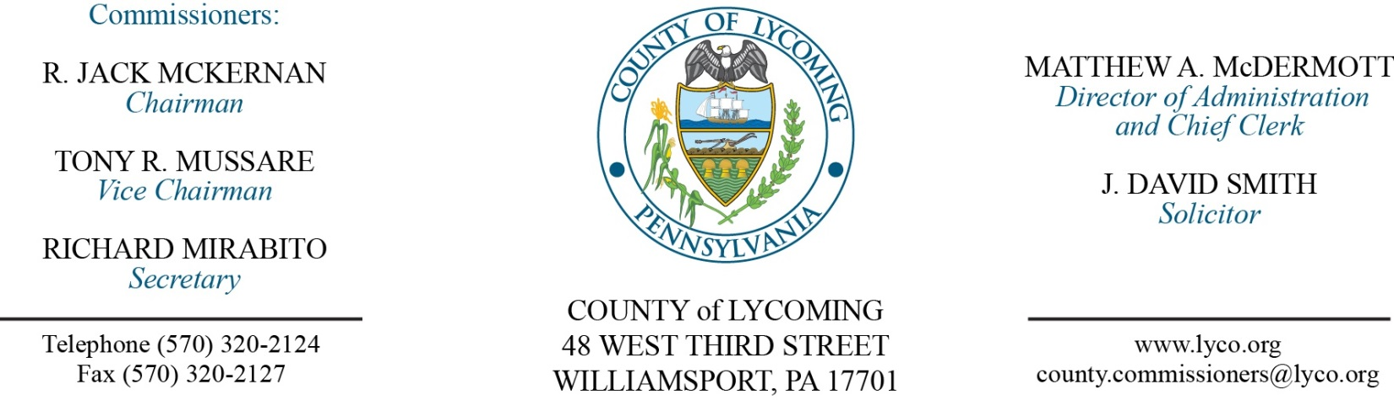
Commissioners’ Meeting Agenda
November 17, 2016

Opening Prayer

Pledge to the Flag

1.0 OPERATIONS

1.1 Convene Commissioners’ meeting.

1.2 Approve the minutes of the previous meetings.

1.3 Receive public comments (agenda items only).

2.0 ACTION ITEMS

2.1 Adopt resolution 2016-26 for surplus items valued under $1,000. (Mya Toon)

2.2 Adopt resolution 2016-27 for surplus items valued over $1,000. (Mya Toon)

2.3 Approve Lycoming County Intermediate Punishment Program grant from PCCD in the amount of $954,631. (Mya Toon)

2.4 Approve maintenance and service agreement for SAVIN for the Prison for a period of one year in the amount of $4,319.52. (Mya Toon)

2.5 Approve correction to agenda item 2.2 from October 20, 2016, changing the quote from Watertronics to Atlantic Irrigation for vertical turbine proposal for WDGC in the amount of $18,100. (Mya Toon)

2.6 Approve correction to agenda item 2.3 from October 20, 2016, changing the quote from Watertronics to Atlantic Irrigation for control panel proposal for WDGC in the amount of $54,727. (Mya Toon)

2.7 Approve professional service agreement with Best Line Leasing, Inc. for a period of ten years on an as needed basis. (Mya Toon)

2.8 Award contract to Seedway, Inc. for Seed & Fertilizer & Erosion Control Materials & Supplies on an as needed basis. (Mya Toon)

2.9 Approve amendment to subrecipient agreement with STEP for Medical Assistance Transportation Program (MATP). (Rachelle Abbott)

2.10 Approve nutrient credit trading contract with Capital Region Water. (Megan Lehman)

2.11 Approve amendment 3 to professional services agreement with TRC Environmental Corp for environmental assessment service for the Brownfields Program. (Megan Lehman)

2.12 Approve amendment 4 to agreement with Pennsylvania College of Technology for the ShaleNET program extending it to December 31, 2017. (Megan Lehman)

2.13 Approve professional service agreement with eciWireless not to exceed $24,940. (John Yingling)

2.14 Approve grant agreement with Commonwealth of PA for Hazardous Materials Response Fund in the amount of $38,956. (Darla Greiner)

2.15 Approve Poll Worker Pay increase as follows effective January 1, 2018: (Forrest Lehman)
Base Compensation for Election Day
Judge of Elections $130.00
Inspector of Elections $120.00
Clerk .... $120.00
Machine Operator $120.00
Constable $120.00
Half-Day Worker $ 60.00
Equipment Pickup before Election Day
$ 5.00 per voting machine
(Paid to 1 election worker) $ 6.00 for supplies
$ .44 per mile
Equipment Return on Election Night
$ 20.00
(Paid to 2 election workers) $ .44 per mile for 1 worker only
Annual Training $ 25.00
(Paid to Judges and Inspectors)

2.16 Approve the following personnel actions: (Roxanne Grieco)
RMS – Resource Recovery – Jason R. McCollum as full time replacement Truck Driver (drop-off) – Pay grade 6 - $21.2466/hour effective 11/20/16.
RMS – Dennis M. Brewer as full time replacement Resource Recovery Supervisor – Pay grade 7 - $18.72/hour effective 11/20/16.
Prison – Zachariah J. Zelewicz as full time replacement Maintenance III – Pay grade 8 - $19.61/hour effective 12/19/16.
Domestic Relations – Cynthia M. Burnett as full time replacement Clerk III – Pay grade 4 - $13.81/hour effective 11/21/16.
Prothonotary – Roxanne N. Myers as full time replacement Clerk III – Pay grade 4 - $13.81/hour effective 11/21/16

5.0 REPORTS/INFORMATION ITEMS

5.1 Lycoming County is requesting proposals for floodplain housing remediation. (Mya Toon)

5.2 LCRMS is requesting bids for Tire Recycling. (Mya Toon)

6.0 COMMISSIONER COMMENT:

7.0 PUBLIC COMMENT:

8.0 NEXT REGULARLY SCHEDULED MEETING: Planning Session on Tuesday, November 29, 2016. No meetings November 22 & 24.

9.0 ADJOURN COMMISSIONERS’ MEETING.

